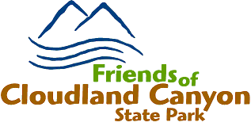 | General Meeting Minutes  January 22, 2026

Attendance was taken using a tablet computer. Meeting called to order by Dena at 6:03 PM. A variety of drinks and snacks were set up by Ginny for all to enjoy.

Dena welcomed everyone and asked each visitor to stand and briefly introduce themselves. She was pleased we had several visitors.
It was encouraging that several of the first time visitors expressed interest in volunteering.
Dena explained that volunteer hours from 2025 need to be entered in the State Friends system by January 31, 2026.

Jim Wilbacks explained that name tags, hour bars and park passes are based on the number of hours a volunteer has reached. He said we (FOCCSP) receive money for each volunteer hour and that is our source of funding events we sponsor.

Gary, Charles and Leon spoke about the trails and the importance of trail maintenance. There are about 64 miles of trail in the park and hence it takes a lot of time to keep properly maintained. They spoke about our Friends of Cloudland Canyon website and that you can report trail issues on the site. You can also adopt a trail and provide the basic maintenance needs for that trail on your personal time schedule.
Ginny spoke about the events she is involved with and encouraged others to volunteer to help. She is the lead for the popular Hayrides that occur in October.

Harry introduced Sarah and Anna from NoogaSitters. Sarah spoke about the services they offer and the importance of providing the proper training for your pet. NoogaSitters is owned and run by sisters, Sarah Ward and Anna Meiners. They provide dog boarding (both overnight and daycare), training, and socialization services. The primary location is on Lookout Mountain near Cloudland Canyon; Sarah runs a small-scale kennel with a camp-like atmosphere. While staying with Sarah, dogs enjoy a schedule of active playtime in her half-acre play yard mixed with restful times inside her kennel. Sarah emphasizes working with dogs on their social skills while giving them freedom to play and explore. Sarah is a certified dog trainer and provides basic pet-dog training with a focus on helping owners understand their dogs and learn how to meet their needs so that their lives can be harmonious.
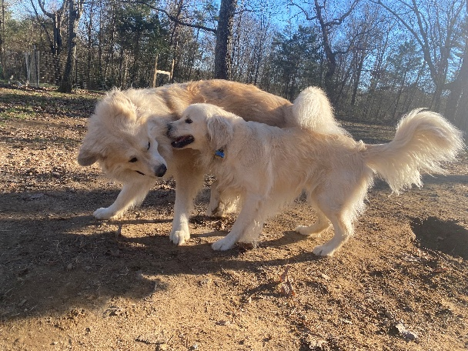

Dena closed the meeting at 6:55 PM

